**TECHNICAL PAPER PRESENTATION FOR A PICOSATELLITE**

**OBJECTIVE :**

In our project, we plan to use a picosatellite for the purpose of monitoring or controlling over a specific large area by linking it with a micro sized drone. This drone can be used for a number of tasks like :

* **Surveillance and gathering intel**
* **Disaster Management**
* **Tracking of moving objects**
* **Collecting information on weather conditions.**

The movement of the drone is controlled using the commands sent by the control system via the satellite.

Hence, the use of picosatellite helps increase the coverage area, which further increases the endurance capability of the drones, as well as allows them to fly at higher altitudes.

**STRUCTURAL DESIGN AND TELEMETRY DETAILS**

**Basis component of a picosatellite**

* **Antenna**
* **Radio transmitter**
* **IC board**
* **Power supply system-solar cells**

**The Pico-satellite Design Concept**

There are two single side piece brackets that make up the modular frame and they are separated by four cross bars referred to as the shear bars. The identical side piece bracket comprises of two bars held in position by another set of cross bars referred to as support bars .This support bar has direct contact with the tie bars, which directly bears the bending moment induced by the PCBs and the mounted components, and also transfers the internal loads to the frame .

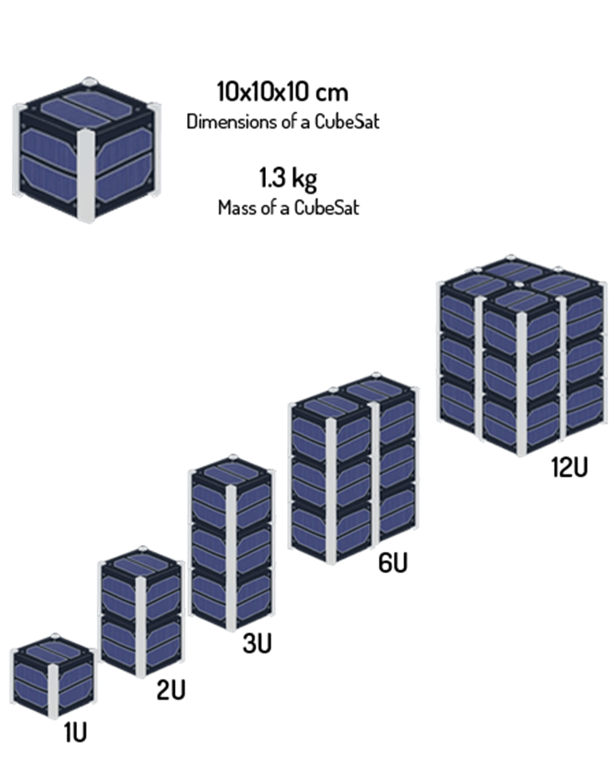

**USES**

The single side piece frames in this design minimize the amount of fasteners thereby increase structural strength against vibration. The configuration comprises of four stack up PCBs screwed along tie bars to the support bars, which in turn transfers load to the rest of the frame structure.

The lateral section of the satellite must have its dimension span 100.0 ± 0.1mm in width, while its longitudinal section must span 113.5 ± 0.1mm and the weight is not to exceed 1.33kg. The structure alone should not take more than 30% of the total satellite weight. Similarly, the centre of mass of the satellite must fall within 2cm of its geometric centre**.**

**Material Selection**

A space-approved composite material, namely, HTM143/M55J (6K) Cyanate-Ester/Carbon unidirectional pre-preg made by CYTEC, was selected for the present application. The resulting lay-up is [0/45/90/−45] S, an eight-layer lay-up which ends up to a total thickness of 1 mm.

As the structure consists of both **aluminium** and composite parts, both von Mises and maximum principal stresses were calculated and reported along with the maximum displacements and strain for all cases.

**Material for frame**

In this study, our material of choice for the frame is **Aluminium 6061-T6** due to

a. Its strength-to-weight ratio is very high making it ideal for attaining a light-weight structure.

b. Excellent structural strength and toughness, indicating high stiffness and workability.

c. It has good finishing characteristics and responds well to anodizing.

d. It is readily available and has excellent machinability due to its chip characteristics.

e. Excellent joining characteristics and thermal expansion coefficient similar to that of the Poly-Picosatellite Orbital Deployer (P-POD) material, Al 7075-T73.

**Connectors**

Bolted screw joint connectors were considered for the analysis set up. The material of the screw is space qualified stainless steel (SS304) M3 × 0.45 mm screws

**•The total deformation on the frame due to static loading is very negligible.**

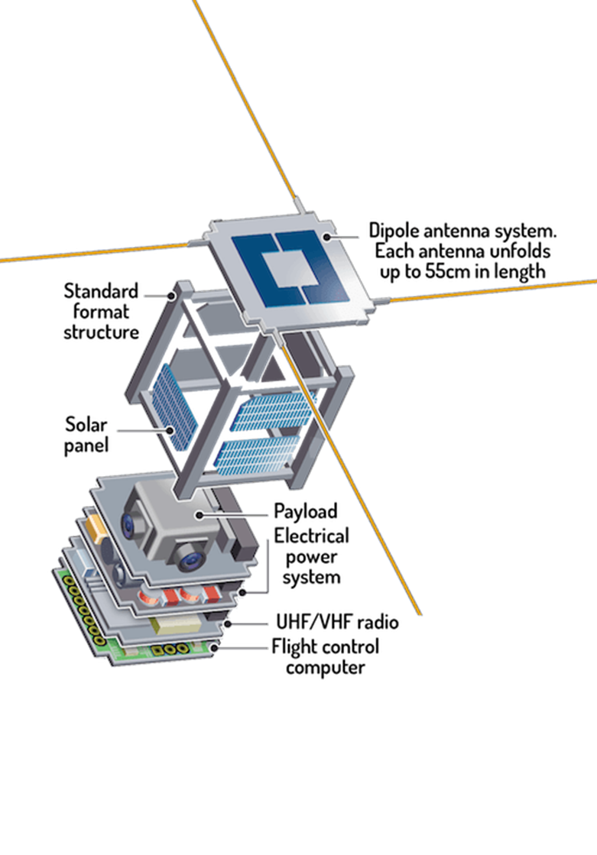

**Materials for Picosatellite Antennas**

**Boards**

Despite their small thickness, commercial and well-characterized boards such as those from Rogers could withstand the high heat illumination during propulsion from ground to space [45, 56]. Besides thickness, these materials must also be light weight to ensure efficient operation in space. The design on the Cube Sat had a size of 39.7 mm(length) × 12 mm(width) and thicknesses of 1.52 mm and 0.508 mm.

**Material**

One of the more popular materials used for small antennas is **the Kapton Polyimide film**. Its advantage include flexibility, good resistance over a number of chemical solvents, and compatibility to high temperatures ranging from −269∘C to +400∘C, making it suited for space applications.

**Membranes**

Membranes have been used as reflectors recently in satellite communications. Featuring a total reflective surface with a diameter of 300cm, it is supported by a canopy built from 40 pieces of tension cables to enable 0.5 focus length to aperture ratio.

**FM Transmitting and imaging Pico-satellite**

The main mission of this study is to deploy a payload, “the Pico-Sat”, from a tower and have it land safely using aero-braking technique based on parachute system. It is also mandatory to acquire and transmit data (telemetry) continuously between the ground station and the Pico-Sat. This paper includes information about innovative designs and analysis for the model satellite. Our Pico-Sat is designed to model satellites which generally have the following common features; sensing, processing, storing sensors data, sending it to a ground station and decision-making in the necessary situations. Tracking down the satellite will be performed by a ground station, which runs on a personal computer as an application with a graphical user interface. All the acquired data can be viewed on the application with proper graphics and tables, as well as providing a flying FM radio station.

**Tracking subsystem**

In order to track the Pico-Sat position and orientation, Inertial Measurement Unit (IMU) readings are obtained along with the GPS readings to precisely track the Pico-Sat in Air, MPU-9150 9-Axis IMU sensor is used as it contains (Gyroscope + Accelerometer + Compass), their readings are combined using complementary filter to give a 3D motion tracking.

**Camera and images storing subsystem**

This subsystem consists of a camera module “**LSY201**” and SD card module to **store the captured image for observation and further processing** after landing, the used microcontroller reads each 32 byte of “JPEG” format of captured image and saves it in a buffer then writes the content of this buffer in an image file created in the SD card via UART (Universal Synchronous Receiver Transmitter) protocol, a tilting mechanism is used to rotate the camera 180 degrees horizontally and 180 degrees vertically to control its direction.

**Atmosphere data collecting subsystem**

This one is responsible for collecting the data about the atmosphere like temperature, humidity, air pressure, this data is very important in environmental experiments. In our system we used “**DHT11**” sensor which measures the **temperature and the humidity** in the form of 4 bytes, the first 2 bytes are the temperature and the remaining bytes are the humidity**, BMP085** sensor which **measures the pressure** and send the value to the microcontroller via I2C protocol.

**Processing unit**

This unit is the mind of our system, it is responsible of many functions such as triggering the sensors like the DHT11, saving other sensors readings in the buffer,etc. We used “**Arduino mega**” as our microcontroller which works with 16 MHZ frequency, it supports many communication protocols like (I2C, SPI, and UART) that are needed to connect the Arduino to other devices, and it also **consumes lower power** so it makes the battery lasts longer.

**Power subsystem**

Sensors and modules are connected through our PCB with a rechargeable **Li-Po battery [11.1V-1100mAh - 25C]** as a power source, enough to power the entire system with full performance for a long time up to **2 hours** based on our calculations. Miniature solar panels are also installed as a source of power.

**FM Radio Station**

One of the most important parts in our mission is the usage of the Pico-Sat as a flying FM radio station, this allowed us to increase the coverage area of the transmission and transmit to different areas. an FM transmitter was designed with a wide range up to 4-5km and connected it to our controller in order to broadcast recorded messages stored on the SD card.

**Secure Data Transmission**

Data sent using ZigBee modules which are encrypted in their communication session using Advanced Encryption Standard with its main functions of mix columns, shift rows, round keys and a substitution table makes it uncrackable. Also to improve the encryption data which is sent in serial is preceded with a letter agreed upon between sender and receiver which is generic and could be changed by configuring the codes from time to time.

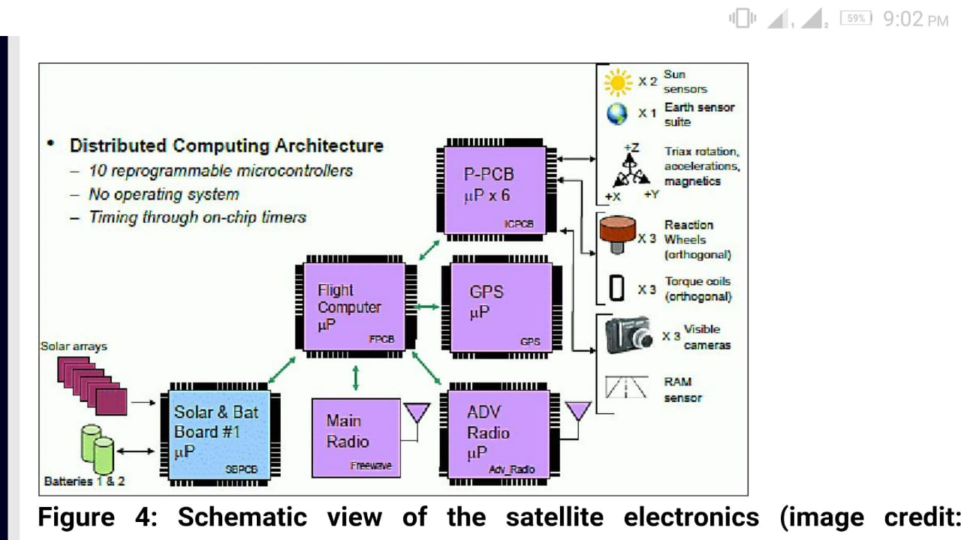

**Sensors to be used:**

**Sun Sensors**  – provides a measurement of one or two angles between the sensor boresight direction and the sun, providing information about the line-of-sight vector to the sun in the satellite body-ﬁxed frame.

**Star trackers** , also referred to as star cameras, are the most accurate type of attitude sensor. Star tracker accuracies range from one arc-second to one arc-minute (0.0003◦ to 0.01◦), depending on the quality of the sensor.

**Horizon sensors** ,also known as Earth sensors ,are infrared sensors that detect the contrast between cold of space and the heat of Earth’s atmosphere. Accuracies between 0.1◦ and 0.25◦ are typical of horizon sensors.

**Magneto meters** measure the direction and magnitude of Earth’s magnetic ﬁeld Attitude-grade magnetometer accuracies typically range from 0.5◦ to 3◦. PNI MicroMag3 three axis magnetometer. The physical dimensions are 2.54 × 2.54 × 1.9 cm3 and the sensor requires 1.5 mW.

**Rate gyroscopes**, also referred to simply as gyros, but are commonly used in spacecraft as they provide a measurement for angular velocity.

**GPS** is also used to reach the desired co-ordinate.

**Three-axis accelerometer** is also installed.

**Calibration of sensors:**

**On-orbit**: This reduces satellite development time and cost through reduction in pre-ﬂight testing and integration requirements. In this dissertation, we develop methods for on-orbit sensor calibration of low-cost sensors that enables unprecedented attitude determination accuracies with these sensors while at the same time minimizing the pre-ﬂight testing and integration requirements.

**COST EFFECTIVE**

The materials and the design of the pico-sat that we have mentioned in this report are affordable at an economic cost.

**DATA LOGGING**

The spatial content in the data log which is also known as the weather parameters is captured using the Temperature and Relative Humidity Sensors accordingly. The CSV file format, XML and HTML is the used to convert the raw data in the data log into reada ble plain text. The Pico-Satellite system made of Structure which houses the electronic subsystem including the on board computer has a direct link to the Xbee Transmitter. The data in the data log is sent via Wireless Communication technology to the Xbee Receiver at the base station with a base station Computer having the s patial information for pico-satellite software is installed. In conclusion, this is geared towards achieving results that is spelt out in the Objectives set for this research.

**SUBMITTED BY:**

**TEAM: Space_Bots**

* SWAROOP KUMAR SAHU
* AYUSH SINGH
* DEBLINA CHAKRABORTY
* KHUSHI AGRAWAL

**VSSUT, BURLA**

**Production Engineering**